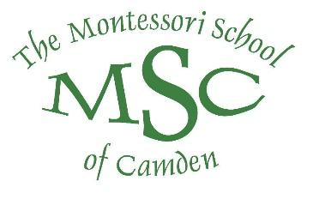

November MSC Board of Directors Meeting
Agenda
November 15, 2022 at 6:00 PM

In Person Meeting at the Catery on Broad (The Paddock)

- Call to Order/Mission Statement Tiffany Atkins, President

- Public Forum/Comment Tiffany Atkins, President

- Approval of 10/18 Minutes Jacqlyn Atkins, Secretary

- Information Session John Li, Charter Institute at Erskine

- Treasurer’s Report Joseph Folsom, Treasurer
- Head of School Report Deb Cyrier, Head of School
  - Together SC

- Committee Reports
- Finance and Audit Joseph Folsom, Treasurer
- Building and Grounds Joan McCulley
  - Safety Committee
- Fund Development Katie Guinn
- Community Relations & Lottery Terri Butts
- Nominating Michael Conley, Vice President
- PAC President Report Carla Norton, PAC President
- Governance/Policy Review Jim Henry
- Strategic Plan Vacant
- Head of School & Board Evaluations Jose Garcia

- Old Business

- Induction of New Board Members Tiffany Atkins, President

- Election of 2022-23 Officers Board Members

- Committee Assignments President

- New Business

- Adjournment

